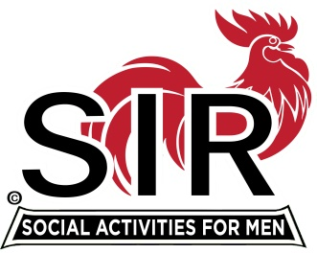
Las Trampas Branch 116
Meeting Agenda
June 21, 2021, 11:30 AM
The Mission of SIR is to enhance the lives of our members through fun activities, events and luncheons – while making friends for life

11:30 am Social Time Breakout Rooms
12:00 pm BIG SIR: Welcome and BIG SIR report
a- “Reopening”

12:10 BIG SIR: Activities Update [Mike Ward]
12:15 Little SIR Speaker Introduction
12:20 Speaker Dan McGovern [formerly from the Justice Department]
12:55 Little SIR Thank Speaker and announce lucky Birthday Boy
13:00 BIG SIR Closing Remarks
*********************************************************************************
Las Trampas Br. 116 Luncheon Meeting
Join Zoom Meeting on June 21, 2021 at 11:30 AM

